1. In object model, objects are associated with each other with object references whereas in Relational model, we use foreign keys.
2. 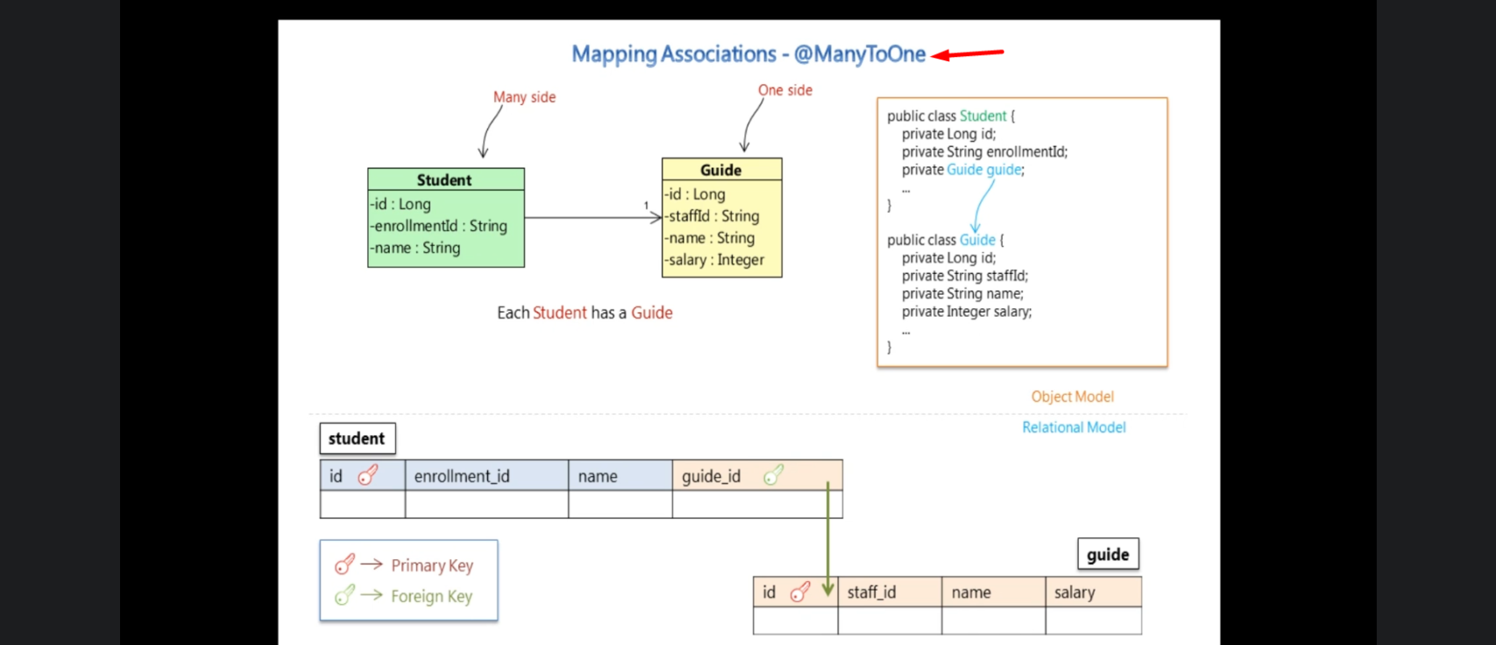
3. **@ManyToOne**: It tells hibernate the relationship b/w the Student Entity and Guide Entity.
4. **@JoinColumn**: Which column in the student is to be used as foreign key column for the guide table.
5. 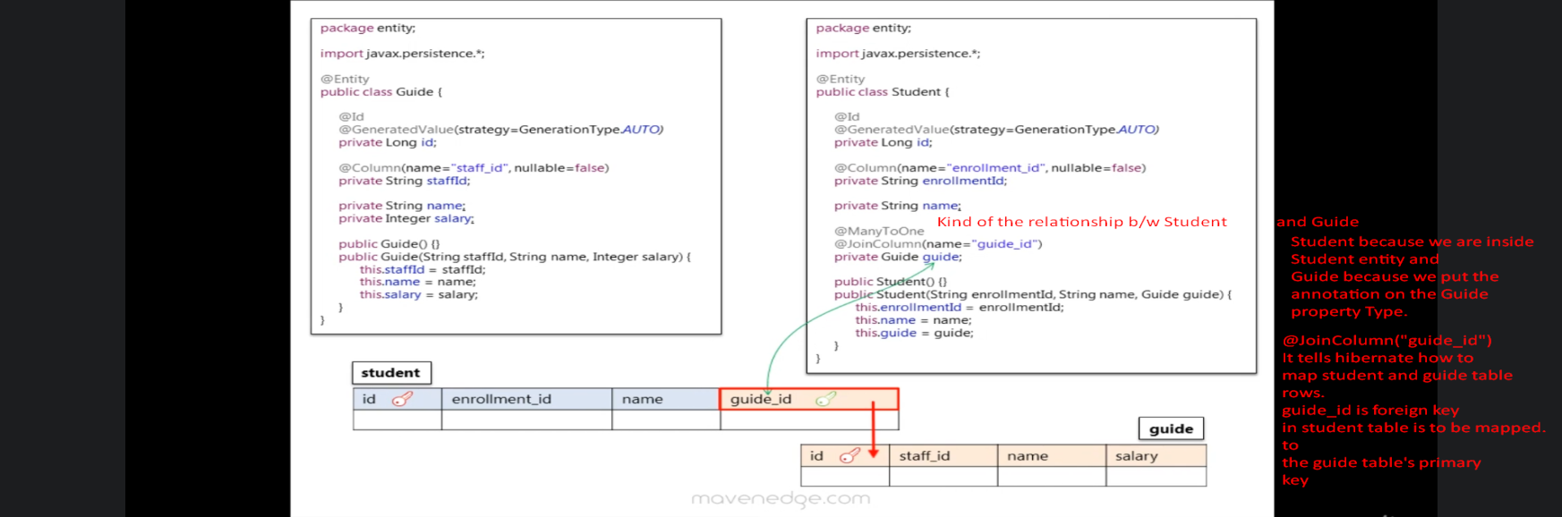
6. 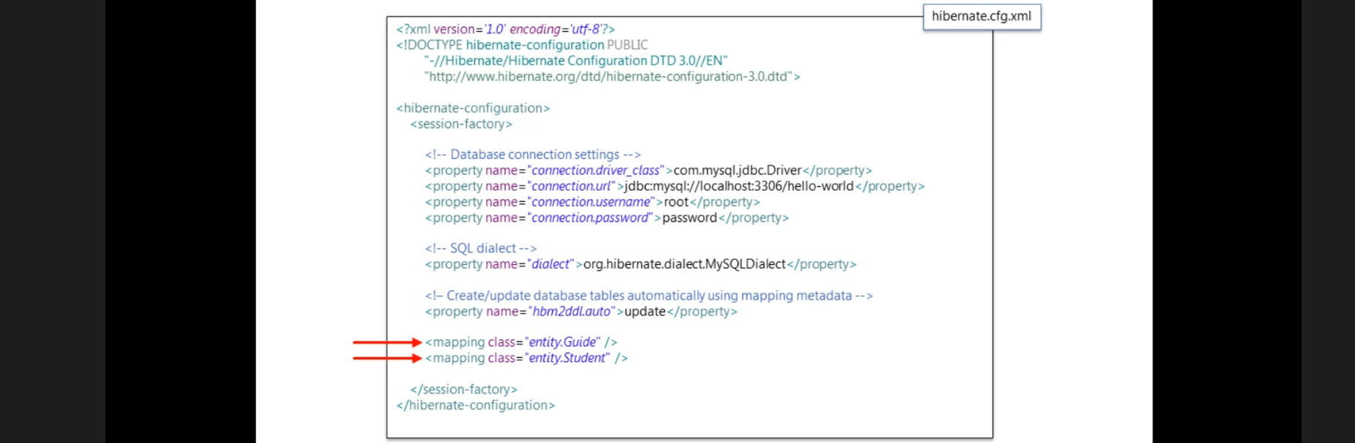
7. 